Business Requirements Document
  - Sehaty HMS

Version: 1.0
Date: October 20, 2025
Prepared By: Sehaty Development Team
Document Status: Draft for Review

Table of Contents
Revision History 4
Executive Summary 5
1. Project Background 5
1.1 Current Situation 5
1.2 Market Opportunity 5
1.3 Problem Statement 5
2. Business Objectives & Success Criteria 5
2.1 Strategic Goals 5
3. Scope Definition 6
3.1 In-Scope for MVP 6
3.1.1 Functional Scope 6
3.1.2 Out of Scope for MVP 8
3.2 Geographic Scope 8
3.4 System Context Diagram: 8
4. Stakeholder Analysis 8
5. Business Requirements 9
5.1 Functional Business Requirements 9
BR-001: User Authentication & Authorization (Must Have) 9
BR-002: Patient Management (Must Have) 9
BR-003: Doctor & Staff Management (Must Have) 9
BR-004: Appointment Scheduling (Must Have) 10
BR-005: Medical Records Management (Must Have) 10
BR-006: Prescription Management (Must Have) 10
BR-007: Billing & Payments with Escrow (Must Have) 11
BR-008: Role-Based Dashboards (Must Have) 11
BR-009: Notification System (Must Have) 11
BR-010: Patient Feedback System (Should Have) 12
BR-011: Multilingual Support (Must Have) 12
5.2 Non-Functional Business Requirements 12
5.3 Data Validation Requirements 12
6. Business Rules 13
6.1 Appointment Rules 13
6.2 Payment Rules 13
6.3 Data Validation Rules 13
6.4 Access Control Rules 13
7. Assumptions 13
8. Constraints 14
9. Dependencies 14
9.1 External Dependencies 14
9.2 Internal Dependencies 14
9.3 Resource Dependencies 15
10. Business Process Changes 15
10.1 Current vs. Future State 15
10.2 Organizational Impact 16
11. Risks and Mitigation Strategies 16
11.1 High-Impact Risks 16
11.2 Risk Response Plan 16
12. Financial Model 17
12.1 Revenue Streams 17
12.2 Pricing (Illustrative) 17
12.3 Unit Economics 17
13. Reporting & Analytics 17
14. Data & Information Architecture 17
15. Acceptance Criteria (Release-Level) 18
16. MVP Delivery Plan & Milestones 18
16.1 Phased Roadmap (8–10 Weeks) 18
16.2 Environments 18
17. Requirement Traceability Matrix (RTM Summary) 18
18. Regulatory & Privacy Cross‑walk (Egypt PDPL – High Level) 19
19. Competitive Landscape 19
18. Glossary 19

Revision History
Version | Date | Author | Description
0.9 | 2025-10-16 | Sehaty Team | Initial draft

Executive Summary
Sehaty is a cloud-based Hospital Management System (HMS) targeting small to medium healthcare providers in Egypt and the MENA region. The platform digitizes core outpatient and administrative workflows to improve efficiency and care quality. Key MVP capabilities include user/role management, patient registration with medical history, doctor and staff scheduling, appointment booking with approvals and reminders, digital medical records, e-prescriptions, billing with an escrow payment model, dashboards, and bilingual notifications.
The MVP will be built using ASP.NET Core Web API with a SQL Server database, and a modern Angular front end (using responsive UI frameworks like Tailwind CSS or PrimeNG). Development will follow an Agile process with iterative releases and stakeholder feedback loops.
This solution aims to:
- Reduce operational overhead (e.g., cut appointment booking time from ~10 minutes to <2 minutes)
- Improve patient care through complete digital records and reduced wait times (targeting a ~30–50% reduction in no-shows and waits)
- Ensure affordability with a 2–6% transaction commission and subscription pricing model, making it accessible to smaller clinics
- Deliver strong user satisfaction (target >85% patient and >80% doctor satisfaction) and system reliability (99% uptime).
By automating scheduling, record-keeping, and billing, Sehaty will replace error-prone manual processes and paper files. Administrators will gain real-time dashboards for capacity, performance, and revenue, while patients can easily book appointments online and view their data securely. The MVP sets the foundation for future expansion into areas like telehealth or advanced analytics while prioritizing core outpatient needs.

1. Project Background

1.1 Current Situation
- Paper-based processes: Many small and mid-sized hospitals/clinics in Egypt and MENA still rely on manual, paper files for patient records and phone-based appointment scheduling.
- Inefficiencies: This leads to long patient wait times, frequent scheduling errors (e.g., double-booking), and difficulty finding past records. On average, booking a new appointment can take ~10 minutes over the phone.
- Data fragmentation: Patient data is scattered (paper folders or isolated systems), impairing continuity of care. Clinicians often lack a complete digital history during consultations.
- Limited oversight: Hospital administrators have little real-time visibility into operations (patient load, revenue, no-show rates), making resource planning hard.
- Cost barrier: Enterprise HMS solutions (e.g., Epic, Cerner) are too expensive and complex for smaller providers. There is a gap for an affordable, easy-to-use system tailored to local needs.

1.2 Market Opportunity
The digital health market in the MENA region is growing rapidly, driven by government initiatives (e.g., Egypt Vision 2030, universal health coverage), rising internet penetration, and lessons from the COVID-19 pandemic. Clinics and small hospitals increasingly seek cost-effective, localized IT solutions. Key drivers include:
- Growing demand: Providers want faster appointment processing, accurate e-records, and transparent billing without heavy costs.
- Budget constraints: Smaller hospitals (50–200 beds) need scalable, subscription-based models rather than large capital investments.
- Bilingual needs: Arabic/English support is essential for regional adoption. A localized interface is a competitive advantage.

1.3 Problem Statement
Small to medium healthcare providers currently face:
- Operational inefficiencies: Manual registration and scheduling processes consume staff time and are error-prone.
- Long wait times: Patients wait hours for appointments or results due to poor scheduling and follow-up.
- Scattered data: Lack of a central database means incomplete patient histories and higher risk of medical errors.
- Limited reporting: Administrators lack dashboards and real-time metrics to monitor performance.
- High costs: Existing enterprise systems are unaffordable, forcing clinics to use no-system or underpowered tools.
Sehaty will solve these issues by delivering a cloud HMS with streamlined workflows, enforcing scheduling rules (e.g., no double-booking), automated reminders, and full digital record storage, all at a fraction of the typical cost.

2. Business Objectives & Success Criteria

2.1 Strategic Goals
- Digitize Core Workflows: Automate patient registration, appointment scheduling, clinical record-keeping, and billing for outpatient services.
- Improve Efficiency: Cut appointment booking time to < 3 minutes, reduce patient wait times by ~30%, eliminate paper records.
- Boost Satisfaction: Achieve patient satisfaction >85% and doctor satisfaction >80% by providing an intuitive system and reducing administrative burdens.
- Drive Financial Viability: Generate revenue via a 2–6% commission on transactions and tiered subscriptions. Reach profitability within 6 months.
- Market Leadership: Position Sehaty as the leading affordable, bilingual HMS in Egypt/MENA, with outstanding usability compared to complex legacy systems.

2.2 Success Metrics (MVP)
Metric | Target | Measurement Method
System Uptime | 99% | Monitoring and uptime reports
Patient Registration Time | <5 minutes | System time-tracking
Appointment Booking Time | <3 minutes | UX analytics
Patient Wait Time Reduction | ≥30% decrease | Clinic analytics, surveys
No-Show Rate Reduction | 50% decrease | Appointment attendance reports
Patient Satisfaction | >85% | Post-visit surveys
Doctor Satisfaction | >80% | Periodic feedback surveys
Annual Customers (Year 1) | 50+ hospitals/clinics | Sales tracking
Revenue Growth (MoM) | 20% | Financial reports
Achieving these targets will demonstrate the MVP’s effectiveness in improving operations and validating the business model.

3. Scope Definition
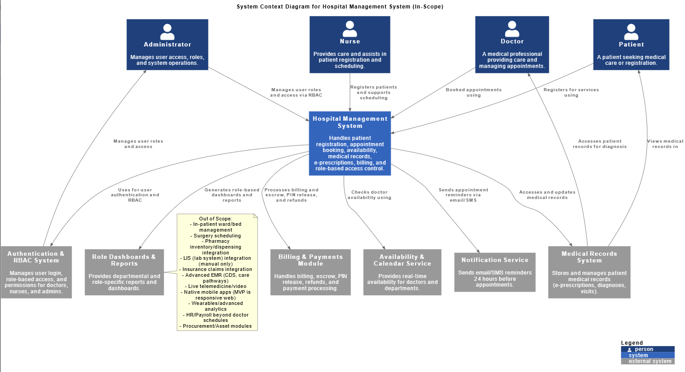

3.1 In-Scope for MVP

3.1.1 Functional Scope
- User & Access Management:
  - Multi-role user accounts (Admin, Doctor, Nurse, Receptionist, Patient) with role-based access control (RBAC).
  - Social login options (Google, Facebook) and standard email/password authentication.
  - Password reset via email, 3-strike lockout (15-minute lockout after 3 failed attempts), and 8-hour session timeout.
  - User profiles capture basic info, Admins can activate/deactivate accounts.
  - Audit logs for login/logout and critical actions.
- Patient Management:
  - New patient registration with demographic details (name, DOB, gender, contact info, address).
  - Unique Patient ID/MRN auto-generation (format “PT-YYYY-NNNN”).
  - Validation: National ID (Egypt) must be exactly 14 digits and unique to prevent duplicates.
  - Medical history: record chronic conditions, allergies, past surgeries, blood type.
  - Upload of documents (ID, insurance, prior medical reports).
  - Search patients by name, Patient ID, phone, or National ID (search results <2 seconds).
  - Patient status tracking (Active, Discharged, Readmitted).
- Doctor & Staff Management:
  - Doctor profiles: name, specialty, department, license number (unique), qualifications, years of experience, photo (optional).
  - Link each doctor to one user account, allow one user to be both doctor and patient if needed.
  - Departments: create/edit departments (e.g., Cardiology) and assign doctors to them.
  - Availability scheduling: doctors set weekly recurring schedules and date-based exceptions (vacations, trainings).
  - Prevent schedule overlaps via unique calendar constraints (no double-booking).
  - Track basic performance metrics (patients seen per day, average rating).
  - Search doctors by name, specialty, or department.
- Appointment Scheduling:
  - Patient (or receptionist on patient’s behalf) can request appointments up to 7 days in advance.
  - Enforce a 30-minute cutoff: no new booking within 30 minutes of slot time. (Emergency override available.)
  - Prevent scheduling in the past.
  - System shows only available slots (according to doctor availability and appointment rules).
  - Appointment approval flow: requests go to the doctor or a receptionist for confirmation.
  - Multiple calendar views: daily/weekly for doctors and staff, showing confirmed/pending slots.
  - Automated 24-hour reminder notifications (SMS/email/in-app) for upcoming appointments.
  - Cancellation policy: patients cancel ≥24 hours in advance for full refund, <24h cancels handled per policy (partial or admin).
  - Allow maximum 2 reschedules per appointment.
  - Emergency appointments: bypass normal rules (can be booked immediately, auto-prioritized).
  - Track no-shows (mark patient if >15 min late without check-in).
- Medical Records:
  - During each visit, doctors create a digital consultation record: symptoms, diagnosis (ICD-10 coding optional), doctor’s notes, and vital signs (BP, temperature, etc.).
  - Attach lab results, imaging files (PDFs, JPG/PNG, DICOM) or other documents.
  - Classify records by type (Diagnosis, Lab Result, Imaging, Follow-Up, Procedure).
  - Maintain a chronological, longitudinal medical history for each patient.
  - Authorized staff (doctor, nurse) and the patient (view-only) can access the record history.
  - Generate printable/downloadable PDF summaries of medical records for sharing or printing.
  - Ensure audit trails (who accessed/modified each record).
- Prescription Management:
  - Doctors create digital prescriptions during the encounter: specify medications, dosage, frequency, duration, instructions.
  - Include physician signature block.
  - Patients view/download prescriptions via their portal (PDF printouts).
  - Track prescription status (active vs. completed).
  - Store prescription history linked to patient and encounter.
- Billing & Payments (Escrow):
  - Automatically generate itemized bills after services (consultations, procedures, lab tests) based on predefined pricing.
  - Support multiple payment methods: credit/debit cards, mobile wallets, bank transfers.
  - Enforce advance payment: payment is captured and held in an escrow account until service is confirmed.
  - Service confirmation via a unique PIN code (sent to patient after consultation) or staff confirmation triggers fund release.
  - Refund process: full refund if cancellation ≥24h before service, partial/admin decision if <24h, refunds processed within 3–5 business days.
  - Commission model: apply a configurable 2–6% platform fee on transactions.
  - Maintain complete payment and billing history for each patient.
  - Admin interface for viewing pending vs. released funds, issuing refunds, and adjusting fees.
- Dashboards & Reporting:
  - Admin Dashboard: Key KPIs (daily patients, revenue, appointment stats, no-shows, occupancy) and charts.
  - Doctor Dashboard: Today’s schedule, patient queue, quick links to create records/prescriptions.
  - Receptionist Dashboard: Pending appointment approvals, today’s check-in list, quick patient search.
  - Patient Dashboard: Upcoming appointments, prescription history, outstanding bills.
  - Nurse/Staff Dashboard: Patient assignments, scheduled vitals recording tasks.
  - Refresh data at least every 5 minutes.
  - Export reports (appointments, financials, patient stats) to PDF or Excel.
- Notifications:
  - Send email/SMS for appointment confirmations, cancellations, and 24h reminders.
  - Notify patients when prescriptions are ready.
  - Send payment receipts and refund notifications.
  - Provide in-app alerts for on-duty staff (e.g., emergency appointment alerts to doctors).
  - Support Arabic/English content in all notifications.
- Patient Feedback:
- After each consultation, prompt patient to complete a brief survey in their portal.
- Allow rating of the doctor (1–5 stars) and comments on service quality, wait time, facility.
- Enforce one feedback entry per appointment per patient.
- Admin dashboard for aggregated feedback analytics (average ratings, comment themes).
- Multilingual Support:
- Full Arabic and English interfaces.
- Language switcher in UI header, remember user preference.
- Implement right-to-left (RTL) layout for Arabic mode.
- Localize date/time formats, number formats, and system messages.

3.1.2 Out of Scope for MVP
- AI Health Risk Prediction for Doctors
- Inpatient ward/bed management, surgery scheduling.
- Pharmacy inventory or automated dispensing integration.
- Laboratory Information System (LIS) integration (manual lab results only).
- Insurance claims processing or integration with insurers.
- Advanced EMR features (e.g., clinical decision support, care pathways).
- Live telemedicine (video conferencing) or triage chatbots.
- Native mobile apps (web app is mobile-responsive for MVP).
- Wearable device integrations or advanced health analytics (deferred to future phases).
- Human Resources (payroll, scheduling) beyond doctor schedules.
- Procurement or asset management modules.

3.2 Geographic Scope
- Primary Market: Hospitals/clinics in major cities
- Target Facilities: Small to medium healthcare centers (approximately 50–200 beds, 5–20 doctors)

3.4 System Context Diagram:
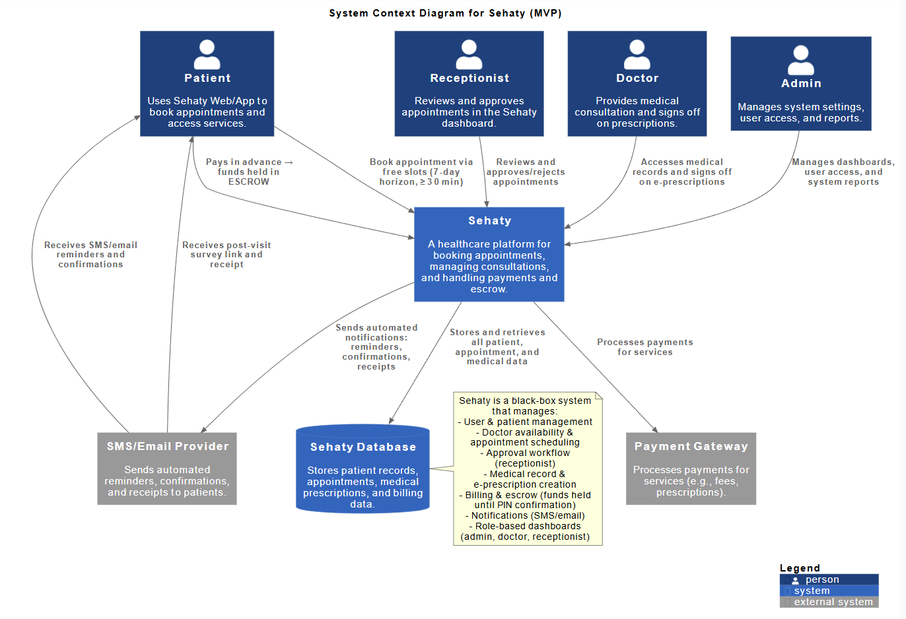

4. Stakeholder Analysis
Stakeholder | Primary Needs | Engagement
Hospital Management | ROI, cost savings, oversight dashboards, compliance | Sponsor, weekly updates
Doctors | Fast access to patient data, easy e-prescribing, reliable schedules | High involvement (requirements, UAT)
Nurses/Medical Staff | Task lists (meds administration, vitals), clear patient info | Medium involvement (feedback)
Receptionists | Quick patient registration, appointment queues, billing | Daily users (usability feedback)
Patients | Simple booking, 24/7 record access, transparency in billing | Indirect feedback (surveys)
IT/Admin | Security, uptime, integration with local systems (e.g., lab) | Tech support (availability reviews)
Regulators | Patient data protection, adherence to standards (ICD-10, etc.) | Compliance checks (low direct)
Each stakeholder group’s needs are reflected in the requirements. For example, management needs drove the dashboard and financial reporting features, while doctors’ needs influenced the focus on complete patient histories and scheduling.

5. Business Requirements

5.1 Functional Business Requirements

BR-001: User Authentication & Authorization (Must Have)
Business Need: Secure, role-based access to protect sensitive patient data and ensure only authorized actions are allowed.
Requirements:
- Multi-role sign-up (Admin, Doctor, Nurse, Receptionist, Patient) with email/username and password.
- Social login via Google/Facebook as an option for patients and doctors.
- Role-Based Access Control (RBAC): Users see menus/features only for their role.
- Enforce password policies (min length, complexity, encrypted storage [bcrypt]).
- Account lockout after 3 invalid attempts (15-minute lockout).
- Session timeout after 8 hours of inactivity.
- Forgot/Reset password via email verification.
Acceptance Criteria:
- Users register/login successfully and see correct dashboard.
- Unauthorized actions are blocked and logged.
- Social logins work seamlessly.
- Locked accounts and password resets function as specified.
Business Benefit: Protects privacy, meets regulatory security standards, and builds user trust.

BR-002: Patient Management (Must Have)
Business Need: A single, accurate digital patient record eliminates paper files and ensures continuity of care.
Requirements:
- Register new patients with full demographics (name, DOB, gender, contact info, address).
- Auto-generate a unique Patient_ID (format “PT-YYYY-XXXX”) and optional MRN.
- Validate national ID (Egyptian ID 14 digits) for uniqueness (no duplicate patients).
- Input fields for allergies, chronic conditions, blood type, etc.
- Upload and attach documents (ID proof, insurance cards, previous reports).
- Patient status indicator (Active, Discharged, etc.) with audit history.
- Search patients quickly by Name, Patient_ID, Phone, or National ID (sub-2 second).
Acceptance Criteria:
- Patient records can be created/edited with all required data.
- The system prevents duplicate entries (national ID check).
- Authorized staff can retrieve and view medical history.
- Search returns correct results rapidly.
Business Benefits:
- Paper record elimination and improved data accuracy.
- Faster patient identification and check-in.
- 24/7 patient access to own information.
- Supports analytics on patient demographics and status.

BR-003: Doctor & Staff Management (Must Have)
Business Need: Efficient management of medical staff and schedules to optimize resource use.
Requirements:
- Maintain doctor profiles: name, specialty, license number (unique), qualifications, years of experience, and department.
- Associate each doctor profile with a user account (one-to-one).
- Allow department admins to create/edit departments and assign doctors.
- Doctors set recurring availability schedules (days/times of week) and one-time exceptions (days off, leave).
- Optionally store profile photo and additional notes.
- Prevent double-booking via unique constraints on doctor schedules.
- Search/filter doctors by name, specialty, or department.
Acceptance Criteria:
- Doctor/staff records are accurate and searchable.
- Availability schedules correctly generate available time slots.
- System blocks overlapping slots.
- Department changes reflect in doctor listings.
Business Benefits:
- Optimized use of doctor time and resources.
- Reduced scheduling conflicts and errors.
- Enables covering shifts (via department info) and planning.
- Data for performance reviews and staffing analytics.

BR-004: Appointment Scheduling (Must Have)
Business Need: Streamlined appointment process reduces wait times and administrative burden.
Requirements:
- Patients can request appointments online (self-booking) or at front desk (staff entry).
- Limits: booking up to 7 days in advance, cannot book within 30 minutes of now.
- Cannot schedule time slots in the past.
- Display only available doctors/slots (based on schedules and existing appointments).
- Appointment request flows to doctor or receptionist for approval.
- Provide daily/weekly calendar views for doctors and staff.
- Send automated confirmation immediately and reminders 24h prior (SMS/email/in-app).
- Emergency appointments override normal timing rules and seek immediate attention.
- Enforce cancellation policy: ≥24h notice for full refund, otherwise partial/admin decision.
- Allow up to 2 reschedules per appointment.
- Track no-shows (auto-mark if patient not checked in within 15 minutes).
Acceptance Criteria:
- Booking completes in under 2 minutes on average.
- System reliably prevents double-booking.
- Calendar views reflect all confirmed and pending appointments.
- Notifications are sent on time.
- Emergency requests bypass standard checks and alert doctor.
Business Benefits:
- Reduced waiting and scheduling errors.
- Better utilization of doctors (no overlaps).
- 50% reduction in no-shows via reminders.
- Improved patient satisfaction (>85% with scheduling).
KPIs: Booking time <2 min, no-shows down 50%, patient scheduling satisfaction >85%.

BR-005: Medical Records Management (Must Have)
Business Need: Digital patient records ensure quality of care, legal compliance, and data longevity.
Requirements:
- Doctors enter encounter details per visit: diagnoses (ICD-10), vital signs (BP, temp, HR, weight), notes, and treatment plan.
- Attach files: lab reports, X-rays, prescriptions (scanned PDFs or images).
- Classify record type (Diagnosis, Lab Result, Imaging, etc.).
- Maintain a chronological medical history timeline per patient.
- Allow authorized viewing by doctors (own patients), nurses, and patients (read-only).
- Generate and download PDF summaries of records or full history.
- Ensure all changes are timestamped (audit log).
Acceptance Criteria:
- New records can be saved and retrieved without errors.
- Attachments open in viewer, correct file types accepted (PDF, JPG, etc.).
- Medical history list shows latest records first.
- PDF exports include all fields and attachments.
- Access permissions enforced by role.
Business Benefits:
- Paper charts eliminated, information instantly accessible.
- Doctors have full history for informed care.
- Audit trail supports compliance (HIS, GDPR/HIPAA principles).
- Faster record retrieval and sharing.

BR-006: Prescription Management (Must Have)
Business Need: Digital prescriptions reduce medication errors and improve patient compliance.
Requirements:
- Doctor enters prescriptions electronically: medication name, dosage, frequency, duration, notes.
- Each prescription linked to an appointment/medical record.
- System stores a running history of all prescriptions per patient.
- Patients view/download prescriptions via their portal (PDF with doctor’s signature block).
- Mark prescriptions as active or completed.
- Alert patients via SMS/email when a new prescription is added.
Acceptance Criteria:
- Doctors can issue prescriptions quickly during visit.
- Patient portal displays current and past prescriptions.
- Downloaded prescription forms include doctor’s name, date, and signature line.
- Pharmacy or patient can clearly read and use the prescription.
Business Benefits:
- Eliminates unreadable handwritten scripts.
- Patients are more likely to follow regimens (digital copy available).
- Improves tracking of medication usage across visits.

BR-007: Billing & Payments with Escrow (Must Have)
Business Need: Transparent, secure billing builds trust, escrow payments protect both patient and provider.
Requirements:
- Generate itemized bill for each completed service (consultations, tests, procedures) based on preset fee schedules.
- Allow partial payments (e.g., deposit for multiple visits package).
- Payment gateway integration (PCI-DSS compliant) for credit cards, local e-wallets, and bank transfers.
- Escrow Flow: Hold payment in escrow after patient pays online. After service completion, a unique PIN (sent to patient) or staff confirmation releases the funds to hospital account.
- Handle full/partial refunds in system based on cancellation rules (full refund >24h, partial/admin if <24h).
- Automatically deduct platform commission (configurable 2–6%) from each transaction.
- Maintain a detailed transaction ledger for patients and the hospital.
- Admin view for pending escrow funds, completed payments, and refund status.
Acceptance Criteria:
- Bills generate automatically and match services rendered.
- Patients can pay and see confirmation receipts.
- Funds release only after PIN or staff verification.
- Refund processing works within specified timelines.
- Commission calculations are correct.
Business Benefits:
- Patient Protection: Money only released when care is confirmed (no advance loss).
- Provider Protection: Hospitals receive guaranteed payment once services done.
- Revenue: Commission fee creates sustainable income.
- Trust: Transparent history of charges and payments.
- Flexibility: Multiple payment options increase adoption.
Business Rules (see Section 6):
- Full refund if appointment canceled ≥24h before (BR-202).
- Partial/admin decision refund if <24h (BR-203).
- Funds released within 24h of confirmation (BR-204).
- Transaction fee 2–6% (BR-205).

BR-008: Role-Based Dashboards (Must Have)
Business Need: Tailored dashboards give each user group the data they need to act quickly.
Requirements:
- Admin Dashboard: Display total patients, daily/weekly appointments, revenue, cancelled/no-show stats, staff utilization.
- Doctor Dashboard: Show today’s schedule, pending requests, upcoming patients, quick links to start consultations.
- Receptionist Dashboard: Show incoming appointments to approve, today’s check-in list, alerts for cancellations/no-shows.
- Patient Dashboard: Upcoming appointment details, prescription list, outstanding bills.
- Nurse/Staff Dashboard: Patient vitals/tasks list for the day, room assignments.
- Dashboards auto-refresh (every 5 minutes) and have print/export (PDF, Excel) options.
- All dashboards available in both languages.
Acceptance Criteria:
- Correct dashboards load immediately after login for each role.
- KPI values are accurate (match underlying data).
- Exported reports open correctly in chosen format.
- Arabic dashboard layout properly RTL.
Business Benefits:
- Decisions driven by real-time metrics (e.g., staffing based on patient load).
- Staff productivity up (no hunting for info).
- Managers get transparency (reducing surprise issues).
- Enhances user experience with relevant data.

BR-009: Notification System (Must Have)
Business Need: Automated communications reduce manual follow-ups and missed actions.
Requirements:
- Trigger email/SMS when appointments are booked, confirmed, or canceled.
- Send reminders 24h before appointments (patient-facing).
- Notify patient when prescription is issued.
- Email receipts after payments and confirmations of refunds.
- In-app alerts for staff actions (e.g., new approval needed, emergency cases).
- Customize notification templates with bilingual content.
- Retry logic for failed sends, logging of all notifications.
Acceptance Criteria:
- Notifications are sent within specified time windows (e.g., confirmation immediately, reminder 24h prior).
- Delivery rates meet standards (e.g., 95% successful SMS).
- Content is correct (patient name, dates).
- Users receive messages in preferred language.
Business Benefits:
- Cuts no-shows by 50% with reminders.
- Reduces administrative calls/emails.
- Keeps patients engaged (e.g., seeing notifications builds confidence in system).
- Rapid escalation for emergencies (on-call doctor alerted).

BR-010: Patient Feedback System (Should Have)
Business Need: Collecting feedback identifies areas for improvement and drives quality.
Requirements:
- After checkout, prompt patient to complete a short survey (email link or in portal).
- Survey covers: doctor rating (1–5 stars), wait time, staff behavior, facility cleanliness, overall satisfaction.
- Limit one survey per completed appointment.
- Allow anonymized feedback option.
- Admin dashboard for aggregated feedback and trends (charts of average ratings, frequency of positive/negative comments).
- Allow hospital admins to respond (internal note) but not publish free-text in patient’s name.
Acceptance Criteria:
- Survey invitation triggers post-appointment reliably.
- Captured ratings aggregate correctly (e.g., average).
- Comment and rating data display on analytics dashboards.
- Privacy: patient identity not shown on public displays.
Business Benefits:
- Ongoing improvement: identifies training or process issues.
- Doctor recognition: highlights high performers via ratings.
- Measures patient satisfaction objectively.
- Provides data-driven quality assurance.

BR-011: Multilingual Support (Must Have)
Business Need: Serve both Arabic and English speaking users in target regions with proper localization.
Requirements:
- Provide full UI text in Arabic and English.
- Language toggle visible on all pages, save user’s choice.
- Implement right-to-left (RTL) layout for Arabic (mirrored menus, right alignment).
- Format dates, times, numbers per language convention (e.g., Gregorian vs. Hijri if needed).
- Translate all user messages, alerts, and notifications.
- Bilingual data entry: allow names and free text to support Arabic script.
Acceptance Criteria:
- All screens show the chosen language without missing labels.
- RTL layout flows correctly (no cut-off text, icons align properly).
- Language switch does not require re-login.
- Translations accurately reflect medical/administrative terms.
Business Benefits:
- Wider adoption across MENA, including rural/Arabic-preferred users.
- Complies with any local language regulations.
- Competitive edge over single-language systems.
- Improves usability and lowers training time.

5.2 Non-Functional Business Requirements
- Performance: Page loads <3 seconds, search queries <2 seconds, support ≥20 concurrent users without slowdown, dashboard refreshes <5 seconds, scalable to 100,000+ patient records.
- Security & Compliance: All data encrypted (AES-256 at rest, TLS 1.2+ in transit), password hashing (bcrypt with sufficient work factor), enforce RBAC in every API, audit logs for all sensitive operations, PCI-DSS for payments, follow local health data laws (e.g., Egypt’s data protection) and general standards (HIPAA/GDPR principles).
- Availability & Reliability: Target 99% uptime (cloud hosting with redundancy), daily automated backups, disaster recovery plan, graceful error handling (user-friendly messages), monitoring/alerts for system issues.
- Usability & Accessibility: Intuitive UI with minimal training (aim for self-explanatory workflows), responsive design for desktop/tablet/mobile browsers, meet WCAG 2.1 Level AA for accessibility (contrast, labels, keyboard nav), consistent look-and-feel across modules.
- Maintainability: Modular codebase (layered architecture), documented API endpoints, standardized coding practices, auto-generate ERD from data dictionary, logging/monitoring hooks for easy troubleshooting.

5.3 Data Validation Requirements
- Uniqueness: Ensure username and email are unique across users, National ID and doctor license number are unique.
- Formats: Patient_ID and Doctor_ID follow “PT-YYYY-NNNN” and “DR-YYYY-NNNN”, name fields accept only letters/spaces, emails follow proper format.
- Password: Min 8 characters, includes uppercase, lowercase, digit, symbol.
- Date Ranges: Date of birth in the past only, appointments cannot be scheduled in the past.
- Appointment Rules: Enforce no overlapping appointments for the same doctor.
- Feedback: Ratings between 1 and 5 inclusive, only one feedback per patient-appointment.
- Billing: Paid amount cannot exceed total due, payments captured only once per bill.
Each input field will have front-end and back-end validation per the data dictionary. Error messages will be user-friendly and localized.

6. Business Rules

6.1 Appointment Rules
Rule ID | Business Rule | Rationale
BR-101 | Appointment can be booked up to 7 days in advance. | Prevents overly long scheduling horizon.
BR-102 | Cannot book within 30 minutes of desired time (except emergencies). | Gives doctors prep time and prevents late changes.
BR-103 | Cancellation requires 24-hour notice for full refund. | Allows rebooking and avoids revenue loss.
BR-104 | Emergency appointments bypass usual time restrictions. | Ensures urgent care is accommodated.
BR-105 | No double-booking: A doctor cannot have overlapping appointments. | Prevents scheduling conflicts (enforced via unique constraint on doctor+slot).
BR-106 | Max 2 reschedules allowed per appointment. | Prevents abuse of the scheduling system.
BR-107 | Patient is marked no-show if not checked in within 15 min of the slot. | Tracks cancellations and enforces accountability.

6.2 Payment Rules
Rule ID | Business Rule | Rationale
BR-201 | Payment is held in escrow until service confirmed. | Protects both patient and hospital.
BR-202 | Full refund if canceled >24 hours before appointment. | Fair cancellation policy for patients.
BR-203 | Partial refund or admin decision if canceled <24 hours before. | Mitigates revenue loss from late cancellations.
BR-204 | Funds released within 24 hours of PIN/confirmation. | Ensures timely payment to the hospital.
BR-205 | Transaction commission is 2–6% (configurable per contract). | Revenue model for platform.
BR-206 | Refund processed within 3–5 business days after approval. | Industry-standard processing timeline.

6.3 Data Validation Rules
Rule ID | Business Rule | Rationale
BR-301 | Egyptian National ID must be exactly 14 digits. | Complies with national standards.
BR-302 | Passwords must be min 8 characters, mixed case, digit, symbol. | Security best practice.
BR-303 | Phone number format 01XXXXXXXXX (Egyptian mobile). | Ensures SMS deliverability.
BR-304 | 3 failed login attempts triggers a 15-minute lockout. | Prevents brute-force attacks.
BR-305 | Session expires after 8 hours of inactivity. | Balances security and convenience.

6.4 Access Control Rules
Rule ID | Business Rule | Rationale
BR-401 | Patients may view only their own records and appointments. | Protects privacy (patient consent).
BR-402 | Doctors can view records of their assigned patients only. | Need-to-know principle for patient data.
BR-403 | Only Admins can delete user accounts or permanently delete records. | Safeguards data integrity and audit trails.
BR-404 | All access to patient data must be logged with user/timestamp. | Audit trail for compliance (HIPAA/GDPR).
BR-405 | Only doctors can create prescriptions for patients. | Ensures medical oversight (license required).

7. Assumptions
- User Assumptions: Staff and patients have basic computer literacy. Each department has at least one internet-connected workstation. Users have email and mobile phones for notifications.
- Technical Assumptions: Hospitals have stable power and reliable internet (min 5 Mbps). They use modern web browsers (Chrome, Firefox, Safari, Edge). Cloud hosting is available and cost-effective. Local payment gateways and SMS providers can integrate with the system.
- Data Assumptions: National ID format is standardized (14 digits). ICD-10 codes will be used for diagnoses (data dictionary in SRS). Historic patient data will be either migrated (via import scripts) or re-entered manually.
- Regulatory Assumptions: Sehaty will comply with Egyptian healthcare regulations (data protection, audit requirements). ICD-10 coding is accepted locally. Digitally signed prescriptions (using doctor’s on-screen signature) are legally valid.
- Business Assumptions: Target hospitals have budget and willingness to adopt new software. Transaction commission and subscription pricing models are acceptable. There is market demand for a localized HMS in MENA. Long-term support and training will be provided by Sehaty.

8. Constraints
- Regulatory: Must adhere to Egypt’s health data protection laws (e.g., personal data privacy). Medical data must follow ICD-10 standards for diagnoses. Audit trails are mandatory. Digital prescriptions must include all legally required information.
- Technical: Web-based only (no native mobile apps in MVP). Must support top modern browsers. Use SQL Server database and ASP.NET Core backend (as specified by project constraints). The system must be mobile-responsive but optimized for desktop use. Minimum support for 20 concurrent users in MVP, scalable architecture for future growth.
- Business: Development timeline is constrained by the academic project schedule. Budget must favor cost-effective solutions (open-source or widely used frameworks). MVP feature scope is strictly limited (as defined above). Initial market focus is Egypt/MENA, but architecture should allow regional customization.
- Language: UI must be fully bilingual. All text content must be localizable. RTL layout for Arabic must be correctly implemented. Domain-specific terms should be accurately translated.
- Integration: Payment gateway chosen must operate in Egypt (e.g., local banks or Fawry). SMS service must support Egyptian mobile networks reliably. Use a secure, HIPAA-compliant email service (e.g., SendGrid, AWS SES). Cloud storage for documents must be encrypted and compliant with health data standards.

9. Dependencies

9.1 External Dependencies
Dependency | Type | Impact if Unavailable | Mitigation
Payment Gateway (e.g., Stripe) | Critical | No online payment processing. | Identify backup (e.g., local gateway) early.
SMS Service (e.g., Twilio) | High | No SMS reminders/alerts. | Fall back to email or local SMS providers.
Email Service (e.g., SendGrid) | Critical | No email communications. | Use secondary SMTP server or provider.
Cloud Hosting (Azure/AWS) | Critical | System offline/unavailable. | Plan multi-region deployment, offline fallback documentation.
SSL Certificate Provider | Critical | No HTTPS (security risk). | Use free CA (Let’s Encrypt) as backup.

9.2 Internal Dependencies
Dependency | Impact if Unavailable | Owner
Complete Requirements Document | No development baseline, scope undefined | Business Analyst
Finalized UI/UX Design (Figma) | Frontend progress blocked | UI/UX Designer
Data Dictionary & Database Schema | Data modeling delays, integration issues | Database Administrator
API Specifications & Integration Plan | Backend/Frontend alignment issues | Technical Lead
Test Data and Scenarios | Inadequate testing coverage | QA Team
Key Stakeholder Availability | Delays in feedback and approvals | Project Manager

9.3 Resource Dependencies
- Availability of developers experienced in ASP.NET Core, Angular, SQL Server, and cloud deployment.
- Access to development, staging, and production environments with proper permissions.
- UI/UX design resources for Arabic and English layouts.
- Budget for third-party services (payment gateway fees, SMS credits, email service).

10. Business Process Changes

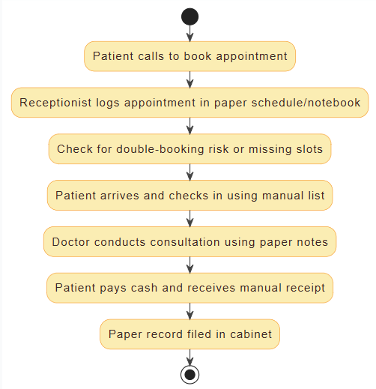
10.1 Current vs. Future State
Process: Patient Appointment Booking
- Current State (Manual):
  - Patient calls or walks in to schedule an appointment.
  - Receptionist consults a paper diary or rudimentary system.
  - Checks for an open slot (often manually, risk of error).
  - Confirms appointment by phone, records details by hand.
  - Writes down appointment on a paper file, no digital confirmation.
  - Possible miscommunications (no reminders, double-bookings).
  - On day of visit, staff search for patient’s paper folder manually.
Pain Points:
- Slow (avg ~10 min per booking)
- Human errors (double-book, lost papers)
- No automatic reminders, poor visibility (no analytics)
- Frustrated patients.
Current (As-Is) booking–visit–payment process
- Future State (Sehaty HMS):
  - Patient books online (portal) or receptionist uses Sehaty interface.
  - System instantly displays available doctors, dates, and times.
  - Patient selects slot, system checks rules (no double-booking, 30-min cutoff).
  - Request is submitted, doctor/receptionist gets notification to approve.
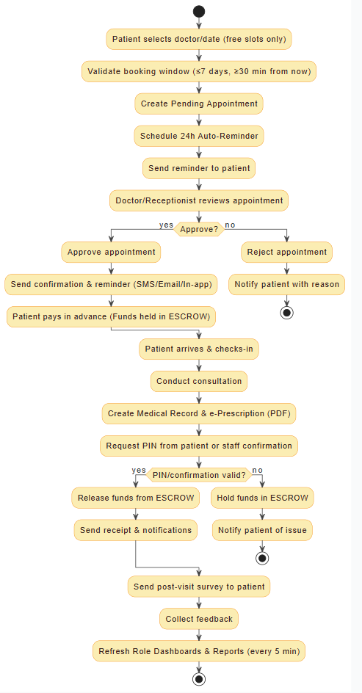
  - Once confirmed, patient receives automatic confirmation SMS/email.
  - 24h before, system sends a reminder.
  - On arrival, receptionist checks patient in via the system, file opens immediately.
Improvements:
  - Booking time: Reduced ~80% (2 min vs. 10 min) through automation.
  - Errors: Zero double-booking with enforced rules.
  - Reminders: 100% automated notifications, reducing no-shows.
  - Visibility: Real-time dashboard shows upcoming appointments and wait lists.
  - Patient experience: Self-service and transparency improve satisfaction.
Process: Medical Records Management
- Current State (Manual):
  - Doctor writes notes and diagnosis on paper chart.
  - Nurse/prep staff file the paper chart in the cabinet.
  - Prescriptions handwritten on pad, patient takes to pharmacy.
  - Patient charts are stored room-by-room, retrieval requires searching physical folders.
  - Risk of lost/damaged files, no remote access by patient.
Pain Points:
- Time wasted retrieving files
- illegible notes
- risk of lost data
- no patient access to history
- manual audits.
- Future State (Sehaty HMS):
  - At each visit, doctor enters visit details directly into Sehaty.
  - Prescription generated digitally and automatically linked to patient record.
  - All records and prescriptions saved in secure cloud storage.
  - On follow-up visits, any doctor in the system can view the complete history instantly.
  - Patients can log into portal to view their own history and e-prescriptions.
  - Automated backups and audit logs ensure no data is lost or tampered.
Improvements:
  - Instant access: No more searching physical rooms, seconds to retrieve a patient history.
  - Legibility: Typed records and prescriptions eliminate handwriting issues.
  - Continuity: Complete, chronological history improves diagnostics.
  - Security: Encrypted storage and daily backups ensure data safety.
Target (To-Be) process with approvals, reminders, escrow & PIN release
  - Transparency: Patients can see and download their records anytime.

10.2 Organizational Impact
- Training: All staff will receive role-specific training (approx. 2–4 hours each). Quick reference guides and videos will be provided. Ongoing support for first month of use.
- Receptionists: Shift from handwritten logs to system entry. Must adapt to the new appointment interface.
- Doctors/Nurses: Will need to enter notes digitally. Change from dictation/paper to laptop/tablet usage. Some may need keyboard training.
- Administrators: Move from manual reports to monitoring dashboards. Will learn new KPIs and report generation.
- Patients: Encouraged to use online booking instead of phone calls. May require guidance on portal use (assisted onboarding for some).
- Change Management: Expect initial resistance from staff used to paper. Mitigation: pilot launch in one department, identify early champions, emphasize time savings. Collect feedback regularly for continuous improvement. Celebrate early successes (e.g., “no errors in bookings week”).

11. Risks and Mitigation Strategies

11.1 High-Impact Risks
Risk ID | Risk Description | Probability | Impact | Mitigation Strategy
R-001 | Scope creep beyond MVP (extra features requested) | High | High | Enforce strict scope control (MoSCoW prioritization), require change review, freeze requirements by end of analysis.
R-002 | Technical challenges with escrow payment implementation | Medium | High | Schedule early tech spike/proof-of-concept for payment flows, evaluate multiple gateways, prepare manual fallback (e.g., confirm via code entry).
R-003 | Staff resistance to adopting new system | Medium | High | Involve users early (requirements gathering, testing), provide strong training, identify super-users, roll out in phases with support.
R-004 | Data migration complexity from existing records | Medium | Medium | Assess data sources early, plan for clean-up or incremental migration, offer manual entry as backup.
R-005 | Third-party service outages (payment gateway, SMS provider) | Medium | High | Use redundant providers where possible, build retry logic, allow fallback communication (e.g., email if SMS fails).
R-006 | Uncovered regulatory compliance issues (late in project) | Low | High | Consult legal/regulatory experts early, schedule compliance reviews at each major phase, maintain change log for audit.
R-007 | Performance bottlenecks under load | Medium | High | Conduct load testing before deployment, design scalable architecture (load balancers, caching), monitor performance metrics.
R-008 | Security breach or data leak | Low | Critical | Engage external security audit, implement strong encryption and logging, perform penetration testing, update promptly.

11.2 Risk Response Plan
- R-001 (Scope Creep):
Freeze baseline requirements by end of design phase.
Continuous review ensures alignment.
Success: <15% scope changes post-freeze.
- R-002 (Escrow Payment):
Allocate development effort early to integrate a test payment gateway sandbox.
Consider alternate simpler escrow methods if necessary.
Success: Working payment/demo model sooner.
- R-003 (User Adoption):
Implement pilot program in one department/clinic 2 weeks before full rollout.
Provide hands-on training and encourage feedback.
Success: Pilot staff report ≥80% confidence in system.
- R-004 (Data Migration):
Inventory existing data formats early.
Develop CSV import tools.
Success: Core patient dataset migrated by pilot launch.
- R-005 (Service Outages):
Contract with at least two vendors for SMS and payments.
Implement monitoring alerts to switch providers.
Success: No critical outages, alternate notifications worked when primary failed.
- R-006 (Compliance):
Regularly review with a clinical/legal advisor.
Document all privacy/security decisions.
Success: No last-minute design changes for legal reasons.
- R-007 (Performance):
Use Azure/AWS autoscaling and optimize queries.
Success: Application supports target load in testing.
- R-008 (Security):
Schedule a third-party security review post-development.
Success: Zero critical vulnerabilities found.

12. Financial Model

12.1 Revenue Streams
- Transaction Commission (Primary):
A 2–6% fee on each paid appointment or service processed through Sehaty (configurable by hospital contract).
Drives revenue proportional to usage.
- Subscription Tiers (SaaS Model):
Monthly subscription plans based on clinic size and features:
  - Basic: For small clinics, core features, higher commission, lower base fee.
  - Standard: More features (e.g., analytics), lower commission.
  - Pro: All features, premium support, lowest commission.
- One-Time License Option:
For on-premise deployment (smaller market initially), with a large upfront fee plus optional annual support.
- Implementation/Training Fees:
Charged to clients opting for professional deployment assistance.
- Notifications Pass-Through:
Include a bundled quota of SMS/email in plans, charge usage fees beyond quota.

12.2 Pricing (Illustrative)
- Basic: Up to 5 doctors, limited SMS (e.g., 100 msg/mo), commission 6%, monthly fee EGP 2500.
- Standard: Up to 15 doctors, 2,000 msgs/mo, commission 4%, monthly fee EGP 7500.
- Pro: Unlimited doctors, 5,000 msgs/mo, commission 2%, monthly fee EGP 15,000.
(Exact pricing TBD after market research)

12.3 Unit Economics
- Costs of Goods Sold (COGS): Cloud hosting, third-party service fees (e.g., 2% to payment gateway on average, EGP 0.05/SMS).
- Gross Margin: Target ≥60% margin when volume scales (lower variable costs per transaction at scale).
- Payback Period: Aim to recover CAC (customer acquisition cost) within first 6 months per customer via subscription and commission.

13. Reporting & Analytics
Operational Reports (exportable to PDF/Excel):
- Daily/weekly Appointment Statistics: scheduled, confirmed, canceled, no-show counts.
- Patient Flow Reports: peak hours analysis (time-of-day booking trends).
- Doctor Utilization: appointments per doctor, idle time.
Financial Reports:
- Revenue Report: Total collected, broken down by service types and by payment method.
- Escrow Status: List of pending releases vs. confirmed revenues.
- Commission Earned: Platform fees collected per period.
- Refunds Log: Details of any refunds issued.
Quality & Feedback:
- Patient Satisfaction: Average rating scores by doctor/department.
- Feedback Trends: Word cloud or frequency of common feedback comments (staffing, facilities).
Scheduled email reports (e.g., weekly clinic summary) can be configured (post-MVP enhancement).

14. Data & Information Architecture
- Core Entities: Users, Patients, Doctors, Departments, Availabilities, Appointments, MedicalRecords, Prescriptions, Bills, Payments, Notifications, Feedback.
- Identifiers: Patient_ID (e.g., PT-2025-0001), Doctor_ID (DR-2025-0001), Appointment_ID, Record_ID, etc. All primary keys unique (system-generated).
- Relationships: (See SRS/ERD for full detail)
  - Users↔Patients/Doctors: Each patient or doctor also has a user account (1:1).
  - Doctors↔Availability: Each doctor has multiple availability slots (weekly recurring + exceptions).
  - Appointments: Links Patient ↔ Doctor, one appointment may have zero or one related Medical Record and zero or more Prescriptions.
  - MedicalRecords↔Prescriptions: Optional linking (not every visit results in Rx).
  - Payments: Linked to Bills (one bill ⇄ many payments possible if partial payments).
- Data Quality Controls: Mandatory fields (per data dictionary) and input masks (e.g., date pickers). Reference lookups for departments and code sets. Referential integrity enforced (e.g., cannot delete a doctor who has appointments). Transactional safety for payments.

15. Acceptance Criteria (Release-Level)
- End-to-End Patient Flow: Patient registration ➜ appointment booking and confirmation ➜ reminder ➜ patient check-in ➜ doctor creates record & prescription ➜ patient pays (escrow) ➜ service confirmation (PIN) ➜ funds released ➜ receipts delivered.
- Security & Compliance: User roles enforced, audit logs available, session timeouts and lockouts functional, HTTPS/TLS everywhere.
- Data Access: Patient can see only their own data, doctors see only their patients. Admin can generate reports on all data.
- Performance: Page load <3s, charts rendering quickly, no system crashes under 20 concurrent users.
- Localization: All user flows work equally in Arabic and English, translations accurate, RTL layout correct.
- Error Handling: Form validation prevents bad data entry, system messages guide the user on error conditions.
All functional requirements above have corresponding user stories/tests in the SRS and will be validated during QA/UAT.

16. MVP Delivery Plan & Milestones

16.1 Phased Roadmap (8–10 Weeks)
- Sprint 0 (Setup): Establish repositories, CI/CD pipelines, set up development/staging environments, create base UI design system.
- Sprint 1 (Core Entities): Implement user auth (register/login, RBAC), patient registration/profile, doctor & department management, basic availability model.
- Sprint 2 (Scheduling): Build appointment booking workflow (request, approval), calendar UI, reminders. Integrate email/SMS notifications for these events.
- Sprint 3 (Clinical Records): Enable medical records (create/view), attachment upload/storage, prescriptions (create/view). Patient portal views for records and prescriptions.
- Sprint 4 (Billing/Payments): Develop billing engine, escrow payment flow, PIN release logic, refund handling, financial reporting.
- Sprint 5 (UI Polish & I18n): Add Arabic translations and RTL adjustments, complete dashboards, implement patient feedback module, finalize all forms.
- Hardening/UAT: Conduct performance tests, security audits, fix bugs, prepare user documentation. Conduct pilot with select clinic. Collect feedback and iterate.

16.2 Environments
- Development: Active coding, unit tests.
- Staging: For integration testing and demos, seeded with realistic test data.
- Pilot (Pre-Prod): Limited rollout in a cooperating clinic for UAT.
- Production: Full launch after successful pilot.

17. Requirement Traceability Matrix (RTM Summary)
The following table maps high-level business requirements to system features and key data entities. Full RTM (with IDs and test cases) will be maintained alongside the SRS.
BRD Section | Feature/Epic | Key Data Entities
BR-001 (Auth) | User Auth & RBAC | Users, Roles, Sessions
BR-002 (Patient Mgmt) | Patient Registration & Profiles | Patients, Users, Documents
BR-003 (Staff Mgmt) | Doctor Profiles/Departments | Doctors, Departments, Availability
BR-004 (Scheduling) | Appointment Booking | Appointments, Availability, Notifications
BR-005 (Records) | Clinical Records | MedicalRecords, Documents
BR-006 (Prescriptions) | E-Prescriptions | Prescriptions, MedicalRecords
BR-007 (Billing) | Billing & Escrow Payment | Bills, Payments, Transactions
BR-008 (Dashboards) | Role-Based Dashboards | Aggregated Views (across Patients, Finances)
BR-009 (Notifications) | Email/SMS System | Notifications, AuditLogs
BR-010 (Feedback) | Patient Surveys/Feedback | Feedback Surveys, Doctor Ratings
BR-011 (Localization) | I18n & RTL Support | UI Localization Files

18. Regulatory & Privacy Cross‑walk (Egypt PDPL – High Level)
This table maps key privacy principles to BRD/NFR items. Exact legal interpretation should be validated by legal counsel.
Principle | Control in System | Where Captured (BR/NFR) | Evidence/Notes
Consent & lawful basis | Explicit consent checkbox during registration; privacy policy link | NFR‑SEC‑PRIV‑01 | Audit log of consent; versioned policy
Purpose limitation | Only collect data needed for booking, billing, records | BR‑PAT‑DATA, BR‑BILL‑01 | Data dictionary scoped to MVP
Data minimization | Optional fields minimized; sensitive fields guarded | NFR‑SEC‑MIN‑02 | PII tagging in database
Access control (RBAC) | Role‑based views (Patient/Receptionist/Doctor/Admin) | BR‑RBAC‑01 | Pen test / access tests
Integrity & accuracy | Edit history, validation rules on inputs | NFR‑DATA‑VAL‑03 | Server‑side validation
Security | TLS, encryption at rest (DB), secrets mgmt | NFR‑SEC‑ENCR‑01 | Config docs / cloud KMS
Breach response | Incident playbook; notification workflow | NFR‑SEC‑IR‑01 | Runbook reference
Retention & deletion | Configurable retention; account deletion request | NFR‑DATA‑RET‑01 | Data purge job / ticket

19. Competitive Landscape
Use this table to capture local competitors and differentiators. Populate with market research (clinic EMR vendors, appointment marketplaces, billing solutions).
Competitor | Type | Key Features | Strengths | Gaps vs Sehaty | Notes/Source
Competitor 1
Competitor 2
Competitor 3
Competitor 4
Competitor 5

18. Glossary
- Escrow: Funds are held in a neutral account until service is confirmed, protecting both payer and payee.
- MRN (Medical Record Number): Unique identifier for a patient’s record history.
- RBAC: Role-Based Access Control — users have roles that determine permissions.
- PCI-DSS: Payment Card Industry Data Security Standard (required for handling card payments).
- ICD-10: International Classification of Diseases, 10th Revision (for coding diagnoses).
- TLS: Transport Layer Security (encryption protocol for network communication).
- UAT: User Acceptance Testing – final validation by end users.
- WCAG 2.1 AA: Web Content Accessibility Guidelines, level AA (accessibility standard).

Appendices

Data Quality & Integrity — Validation Pipeline
Acceptance Criteria — End-to-End Patient Flow (Escrow)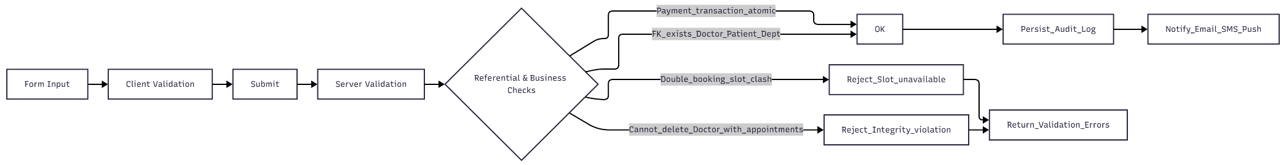

Acceptance Criteria — End-to-End Patient Flow (Escrow)
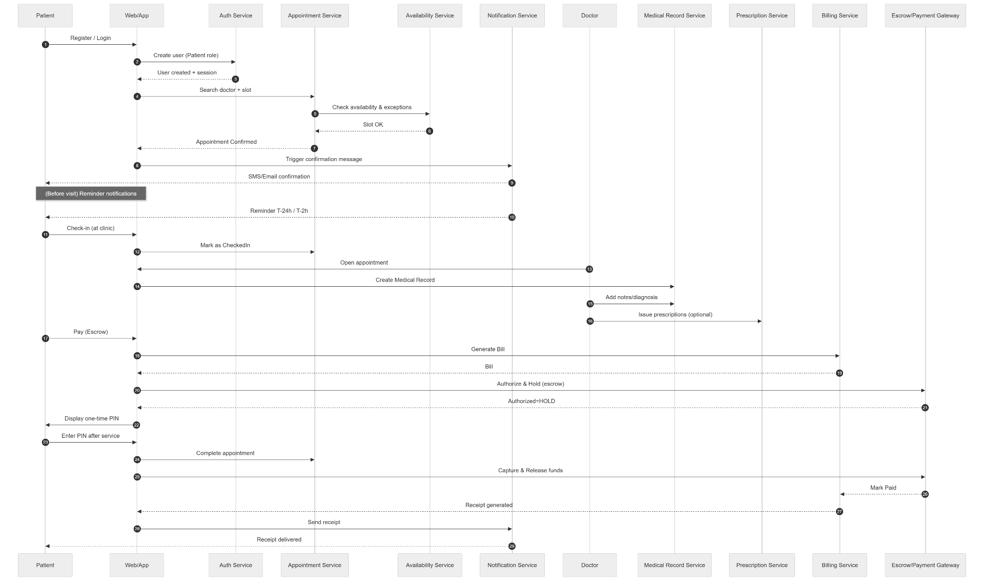
Acceptance Criteria — RBAC Data Access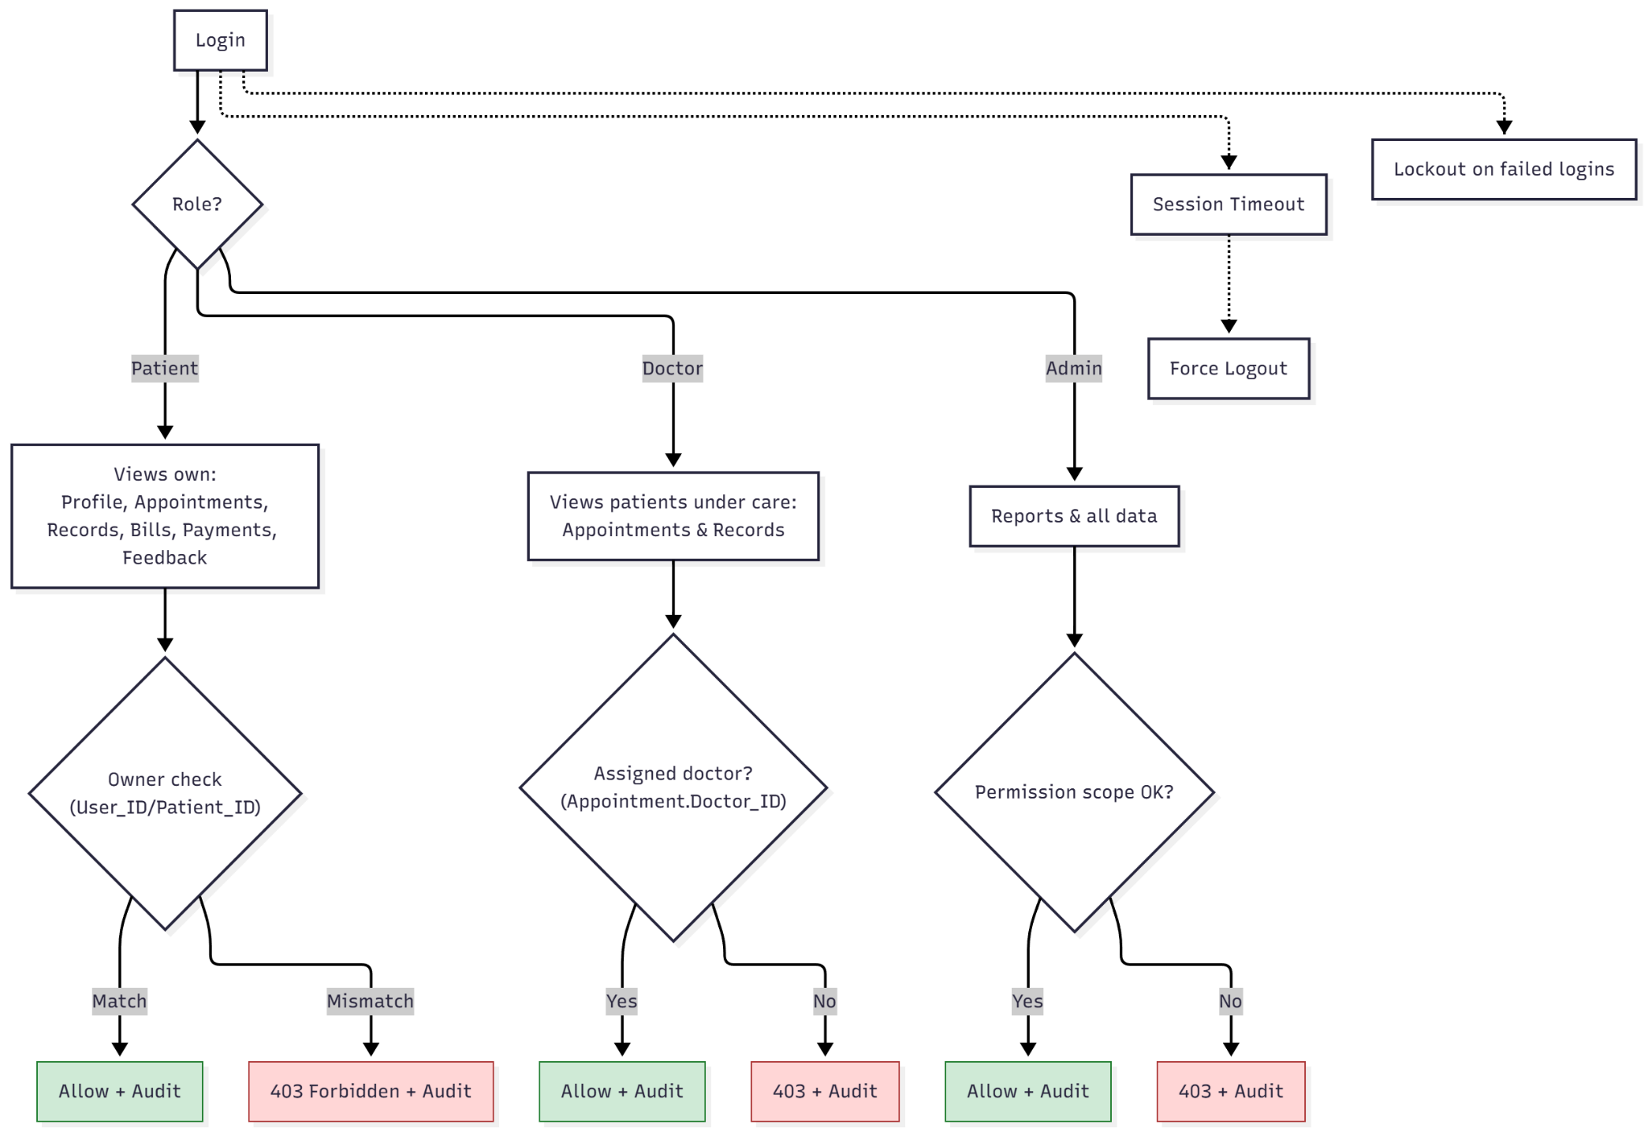

Acceptance Criteria — Escrow Payment Lifecycle
